Department of Computer Science Course Code: CSC-315
Course Title:
Data Warehousing and Data Mining

Spring 2025

ASSIGNMENT

Objective:
ETL Pipeline Development

- Extract the data from the CSV format and push it into another CSV by using ETL.

Implementation:
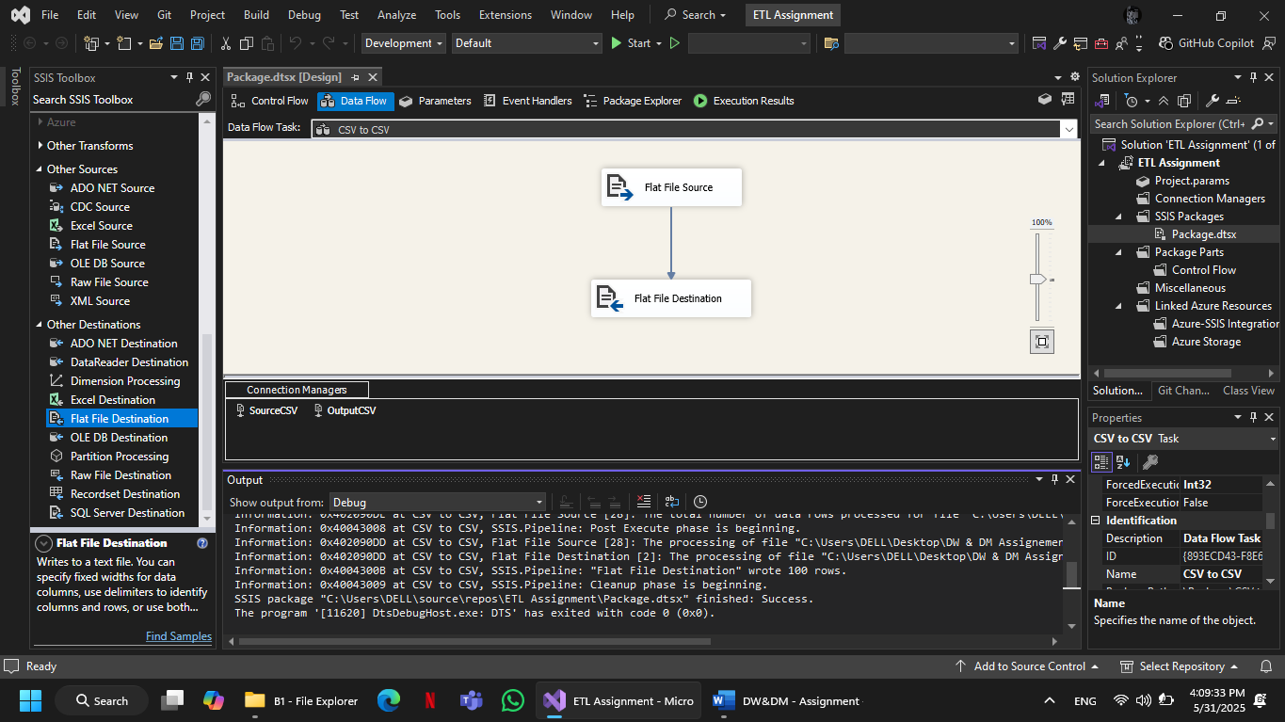

Output:

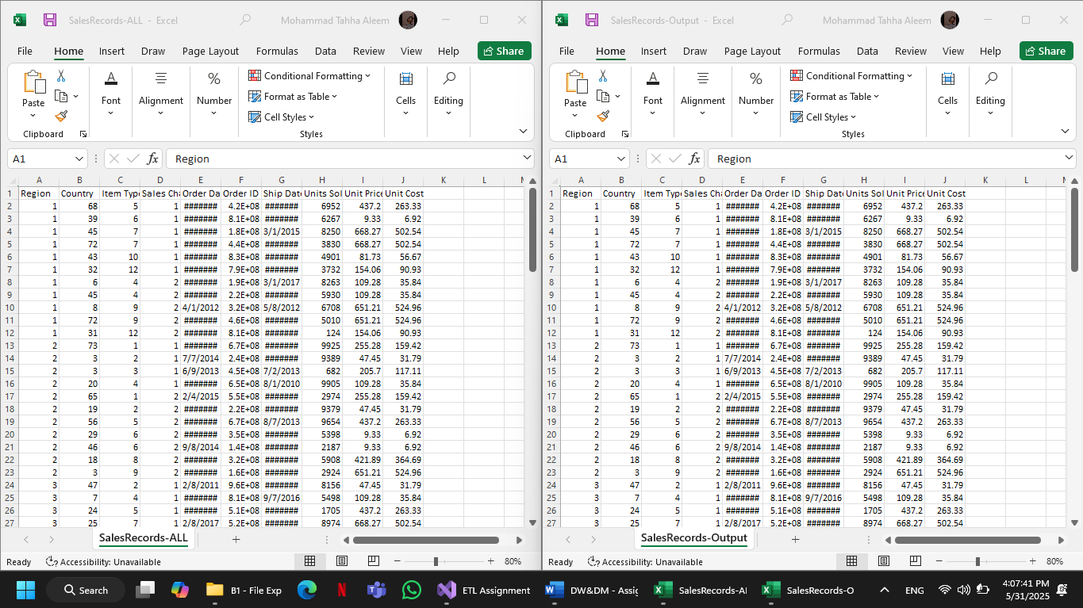

- Extract the data from more than one CSVs apply transformation and load it into another CSV.
Implementation:

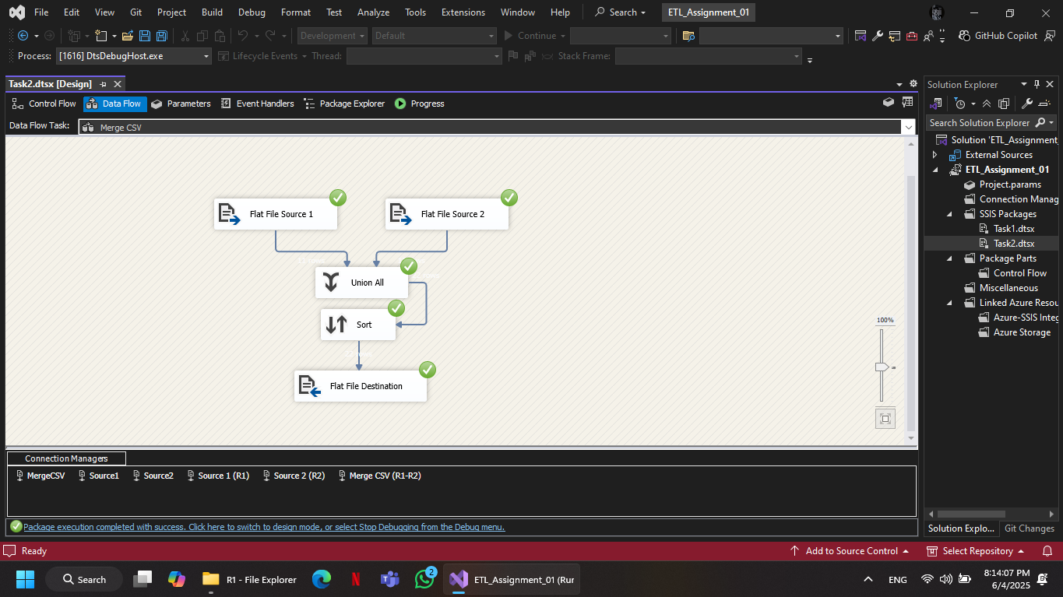

Output:

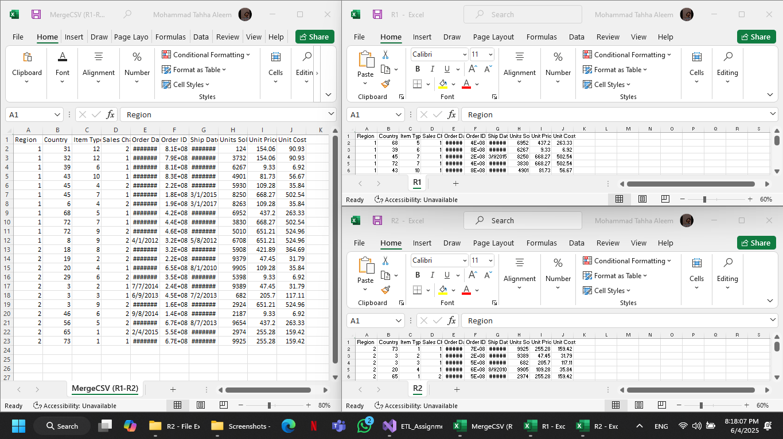
- Extract the data from more than one CSVs apply transformation and push it into the SQL server.

Implementation:

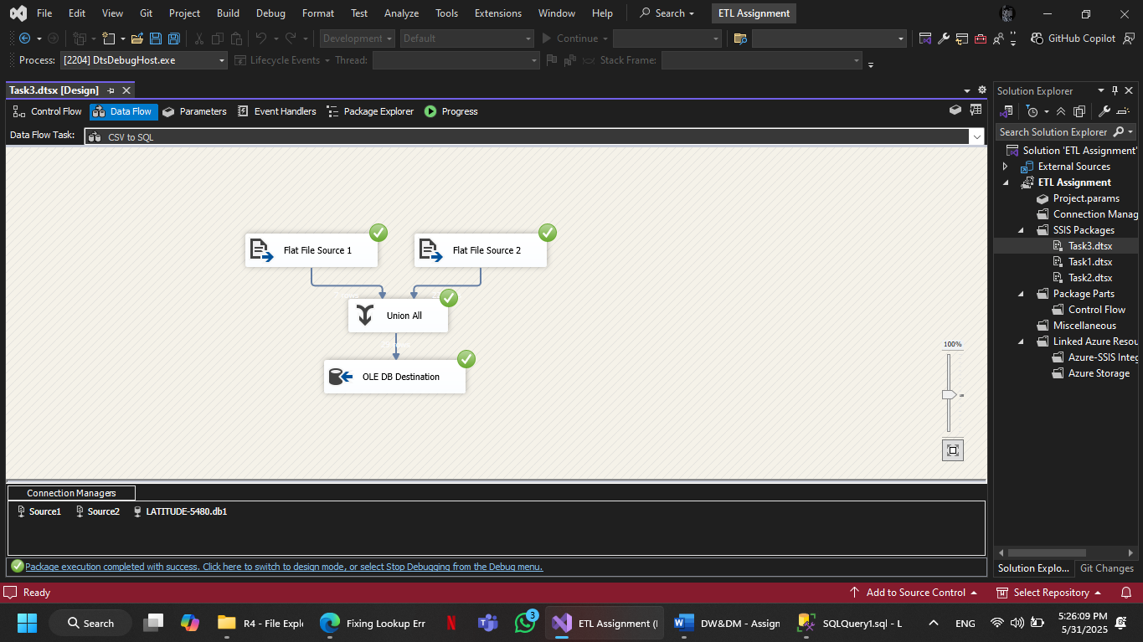

Output:

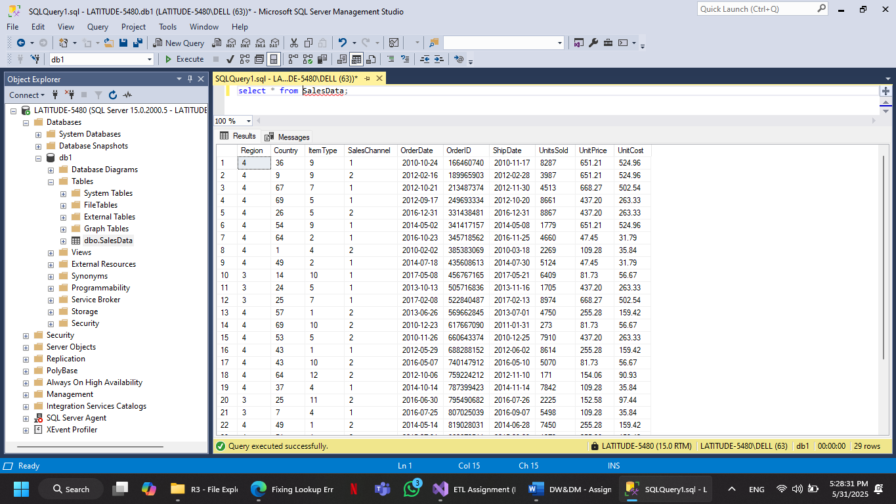
- Extract the data from more than one CSVs and SQL server apply transformation and push it into the SQL server by using scheduled agents.

Implementation:
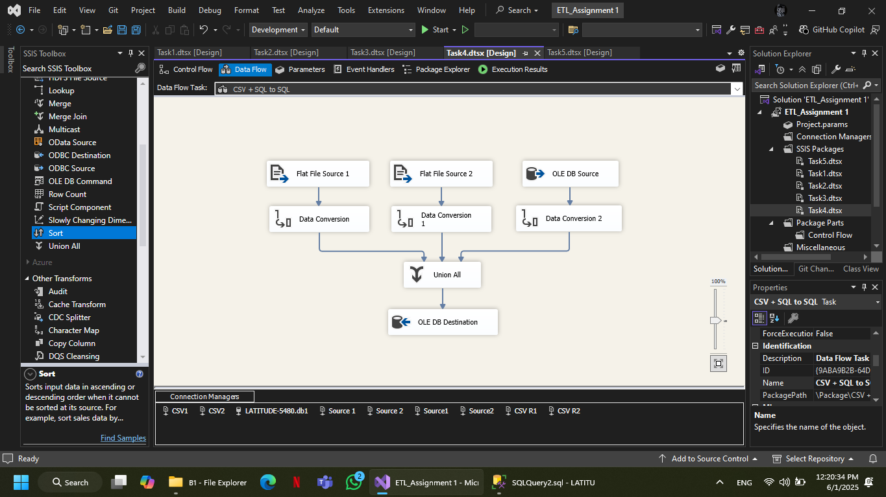

Output:

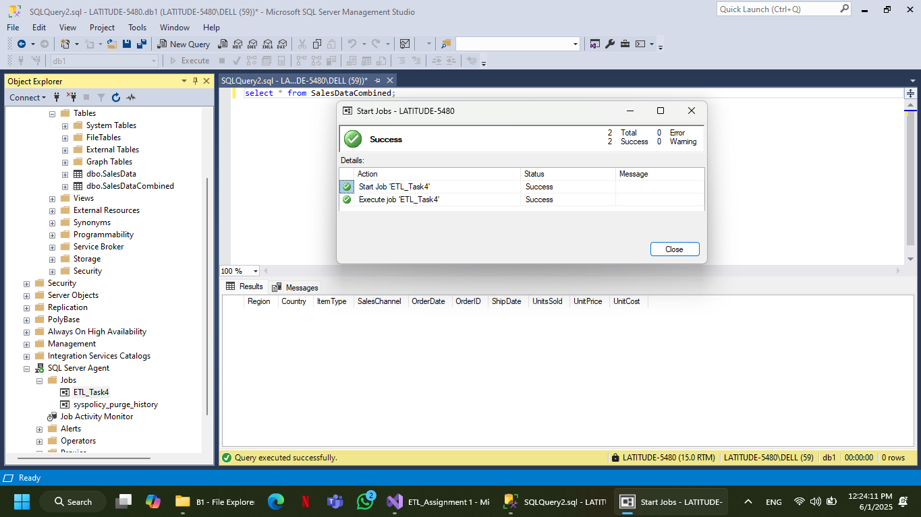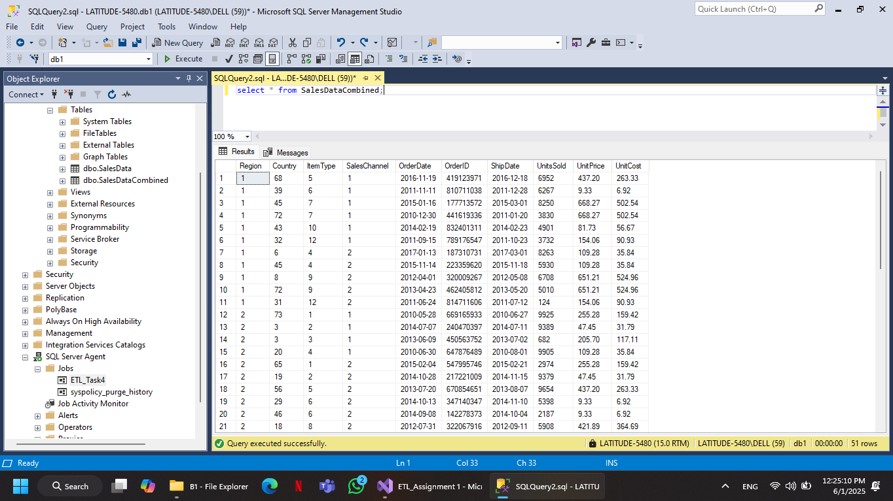

- Use given Data set (B1.zip) containing multiple CSVs. Push them into the SQL server to create the start or snow flake schema.

Implementation:

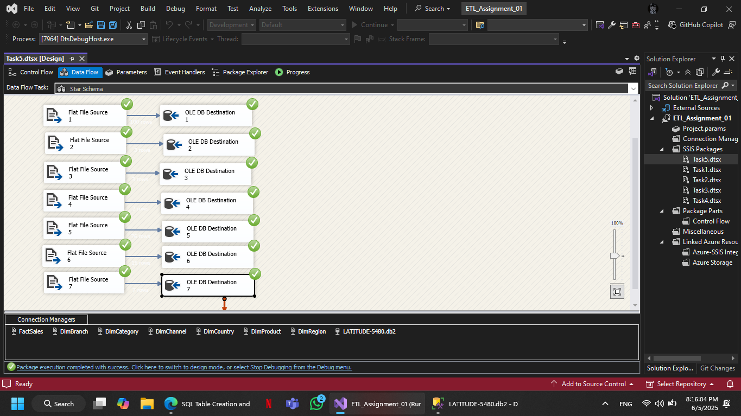
Output:

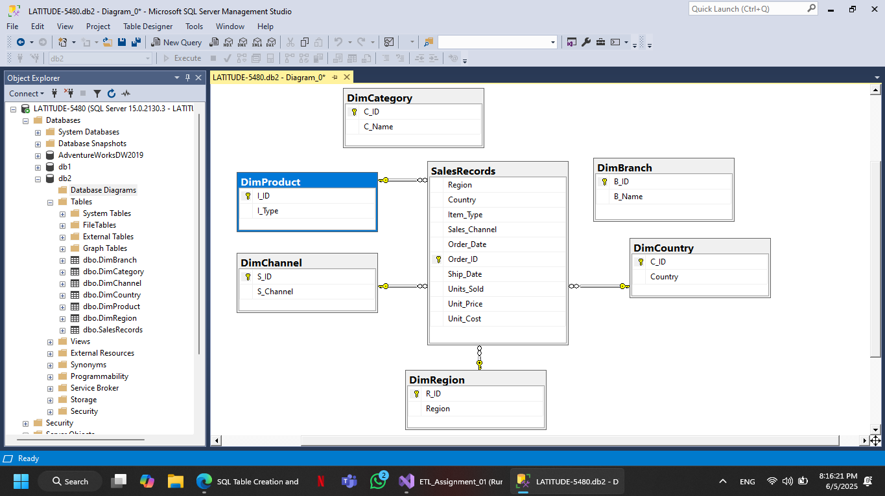
- Use given adventure works data ware house data set for SSAS services by developing OLAP.
Implementation:

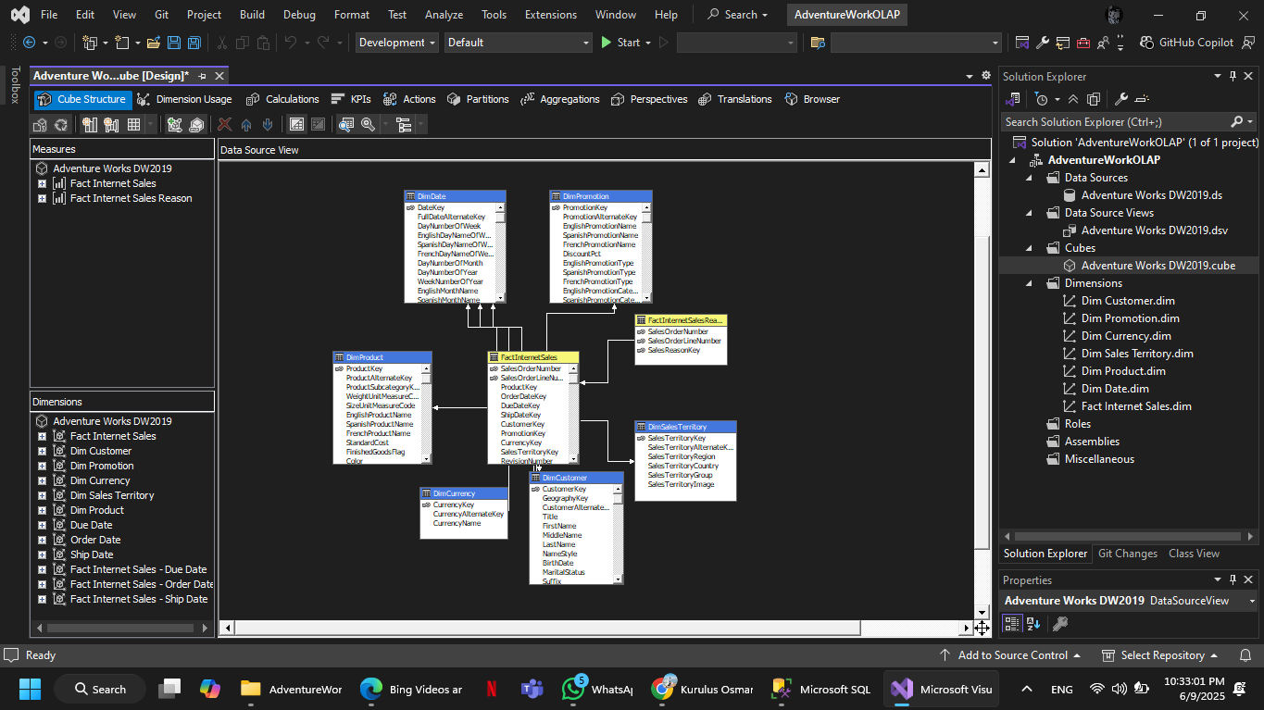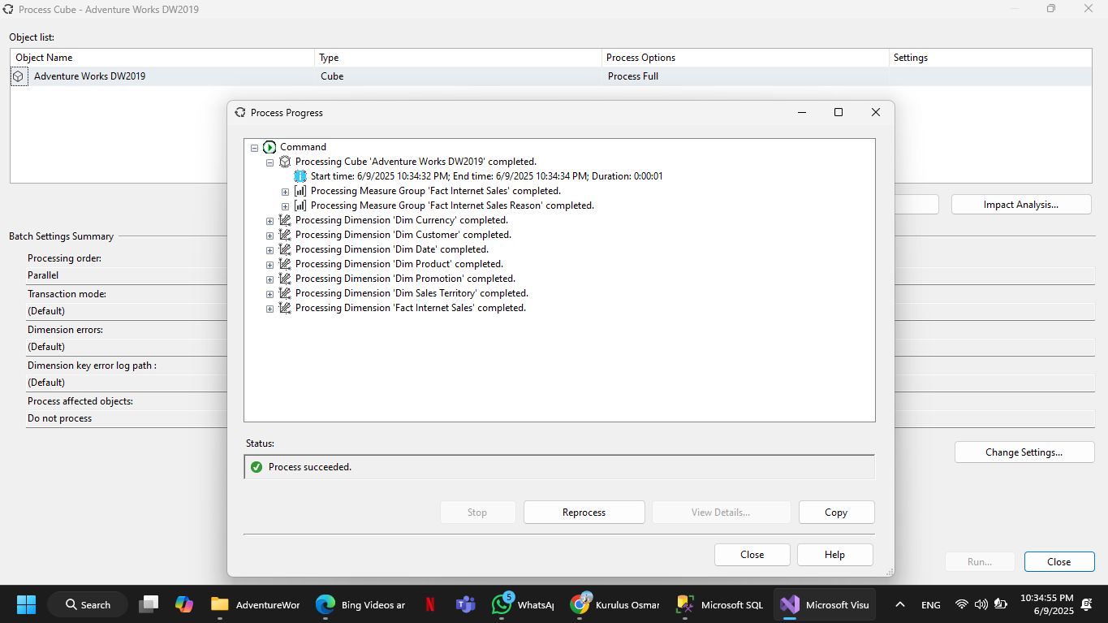

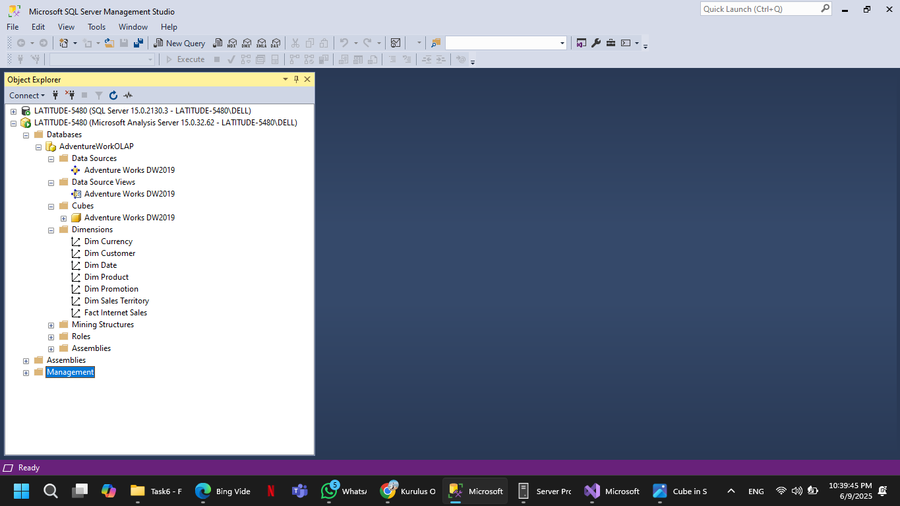

- Use developed OLAP cubes and apply all multidimensional functions.
Implementation:

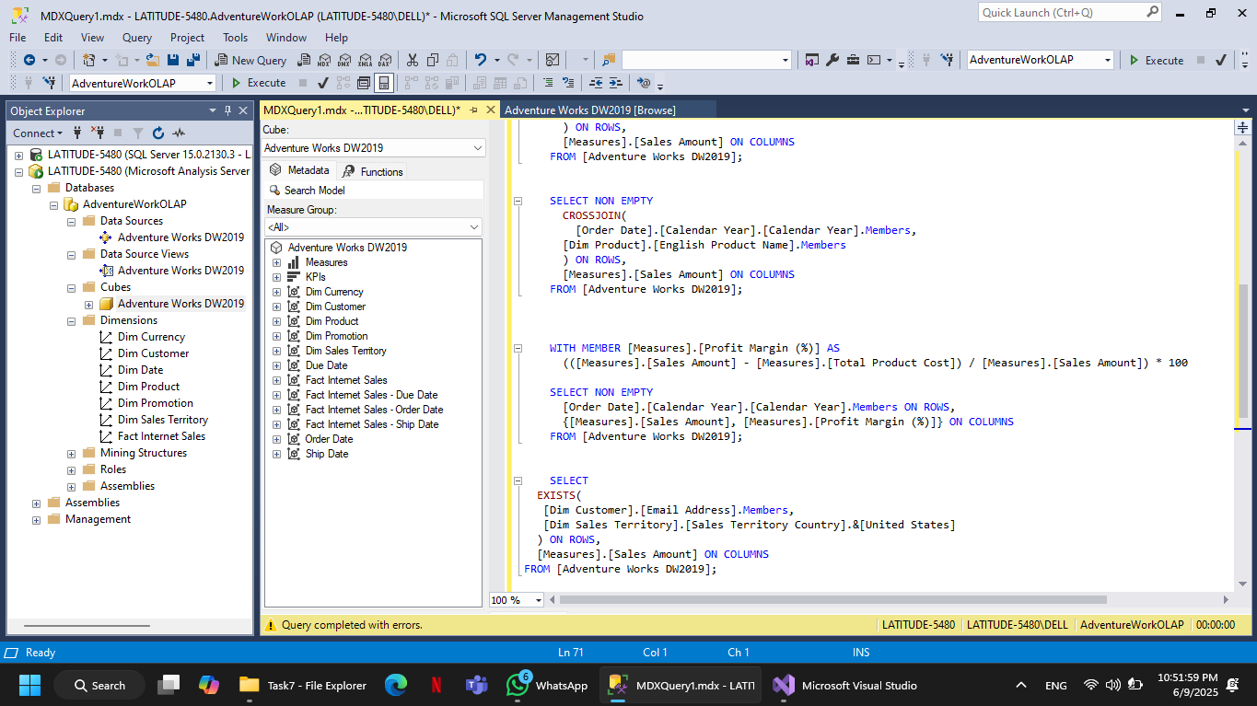

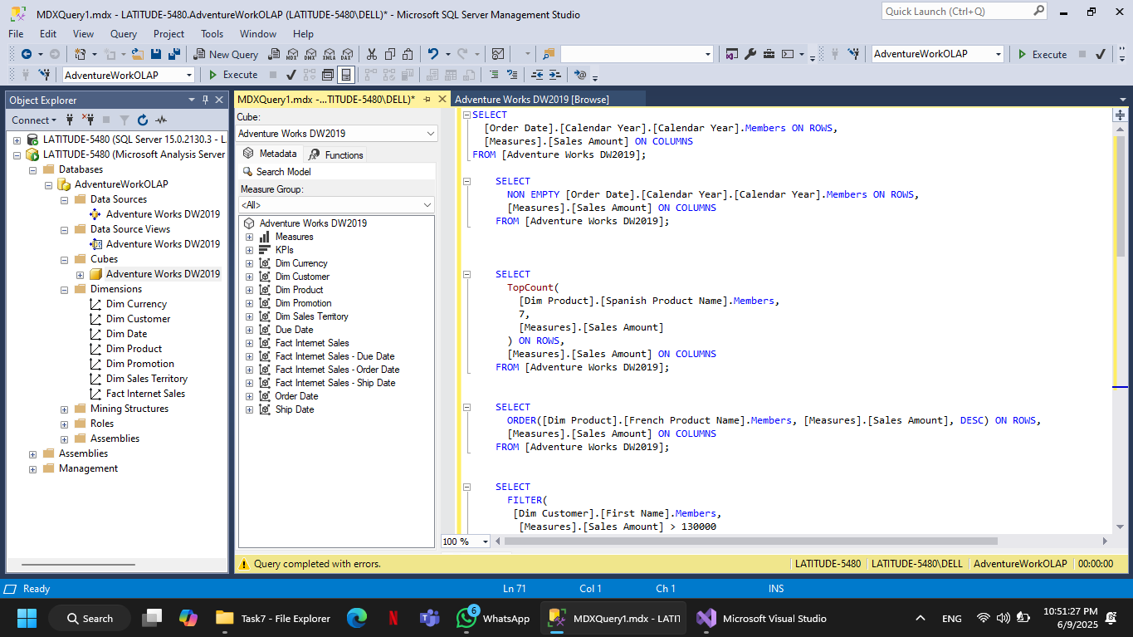
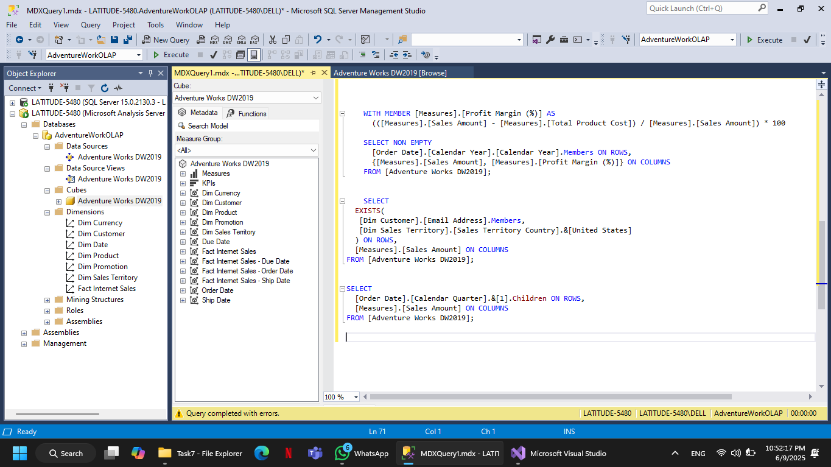

- Use developed OLAP cubes for Data Analytics.

Implementation:

